The application form for Bottland 2019 exhibitor
BOTTLAND CONNECT DEVICE
 |  | VENUE: Crocus Expo IEC
 |  | 19 - 22 February 2019
- ORGANISER
ITE Expo International Limited Liability Company
107140, 3, bld. 2, office 1, Verkhnyaya Krasnoselskaya str., Moscow, Russia |  |  |  |  |  |  |  |  |  |  |  |  |  |  |  | Тel:  e-mail: |  |  |  |  |  | (499) 750 08 28  Larisa.Zhitkova@ite-russia.ru
- EXHIBITOR
(COMPANY NAME / PAVILION, STAND NUMBER)
(CONTACT PERSON) |  |  |  |  |  |  |  | (E-MAIL) |  |  |  |  |  |  |  |  |  |  |  | (TEL NUMBER)
- BOTTLAND CONNECT DEVICE* |  |  |  |  |  |  |  |  |  |  |  | COST
 |  |  |  | Cost of service - 4 days |  |  |  |  |  |  |  |  | 450 €
 |  |  |  | Number of devices **

Specify the type of equipment you are interested in:
table model floor model
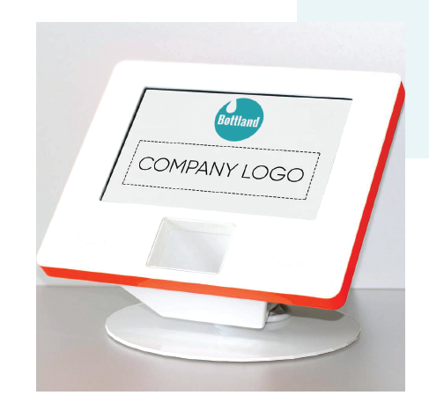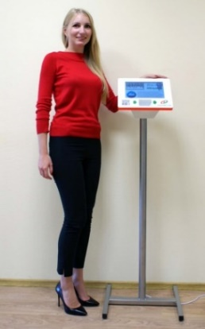

Company details, signature, stamp:

* Includes terminal rental, configuration, installation, technical support during the exhibition, storage of information in your exhibitor's account.
** The recommended number of terminals – 1 device for every 20m2

